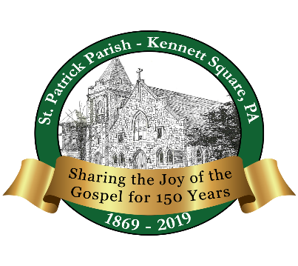
St. Patrick Parish
150th Jubilee Dinner Dance
The mendenhall Inn
Sunday, December 8, 2019

2pm to 3pm Open Bar and Hors d’oeuvres
3pm to 6pm Dinner, Dancing, & Cash Bar
Harvest Salad
Salmon with Crab Imperial
Prime Rib of Beef
Garden Vegetable Wellington
Parmesan Roasted Yukon Gold Potatoes
Vegetable Medley
Fresh Rolls and Butter
Coffee/Tea
New York Cheesecake

Music by: 2uesday Night Band
Ticket Cost: $50.00

